HTML Image Elements

📘 Definition
# Source: AI Source: Provided by: [Data Path: Persons Table -> ID Column: 1, Name_En Column: Motasem Essam] -> From: [ChatGPT] on [5/6/2026]
The HTML <img> element is used to display images on webpages.
Images can be:
- photos
- icons
- logos
- illustrations
- graphics

🌐 Basic Image Example
# Source: AI Source: Provided by: [Data Path: Persons Table -> ID Column: 1, Name_En Column: Motasem Essam] -> From: [ChatGPT] on [5/6/2026]
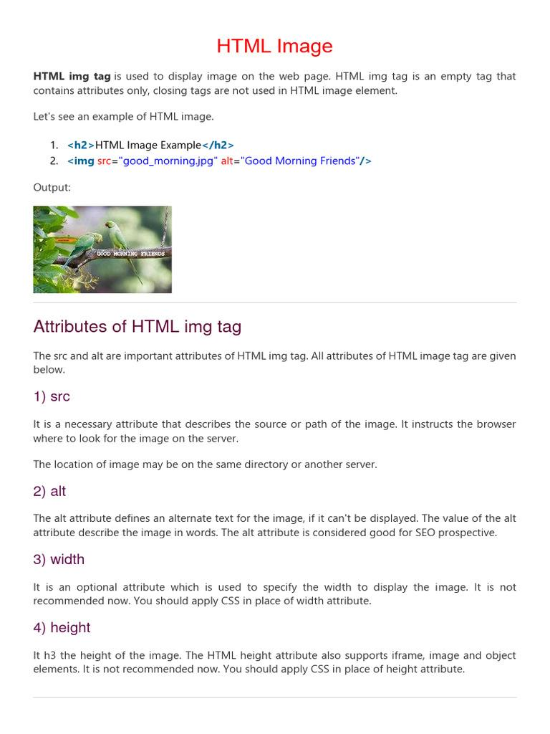
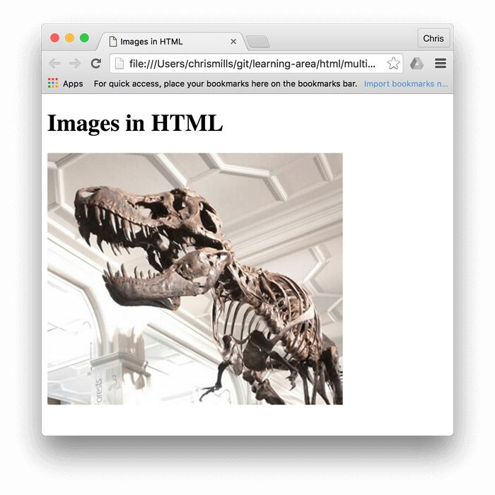
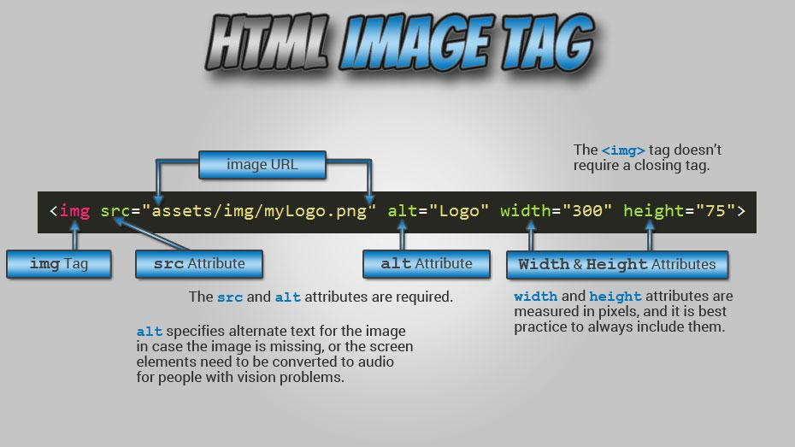
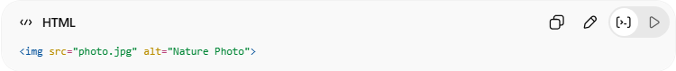
<img src="photo.jpg" alt="Nature Photo">
👉 Displays an image on the webpage

🧠 Main Attributes of <img>
# Source: AI Source: Provided by: [Data Path: Persons Table -> ID Column: 1, Name_En Column: Motasem Essam] -> From: [ChatGPT] on [5/6/2026]
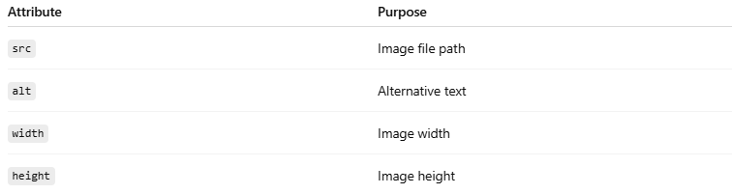
Attribute | Purpose
src | Image file path
alt | Alternative text
width | Image width
height | Image height

🔤 Common Image Features

1. 🖼️ src Attribute
# Source: AI Source: Provided by: [Data Path: Persons Table -> ID Column: 1, Name_En Column: Motasem Essam] -> From: [ChatGPT] on [5/6/2026]
📖 Description
Specifies the image file location.
💻 Example:
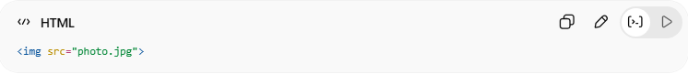
<img src="photo.jpg">

2. 📝 alt Attribute
# Source: AI Source: Provided by: [Data Path: Persons Table -> ID Column: 1, Name_En Column: Motasem Essam] -> From: [ChatGPT] on [5/6/2026]
📖 Description
Displays alternative text if the image cannot load.
Also improves accessibility.
💻 Example:
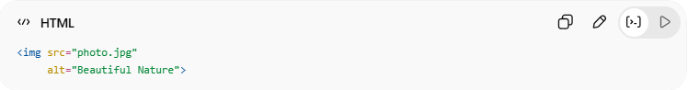
<img src="photo.jpg"
alt="Beautiful Nature">

3. 📏 Width and Height
# Source: AI Source: Provided by: [Data Path: Persons Table -> ID Column: 1, Name_En Column: Motasem Essam] -> From: [ChatGPT] on [5/6/2026]
📖 Description
Controls image dimensions.
💻 Example:
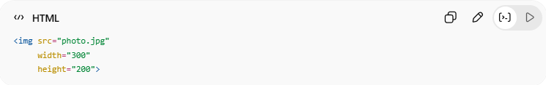
<img src="photo.jpg"
width="300"
height="200">

4. 🔗 Image as a Link
# Source: AI Source: Provided by: [Data Path: Persons Table -> ID Column: 1, Name_En Column: Motasem Essam] -> From: [ChatGPT] on [5/6/2026]
📖 Description
Images can be clickable links.
💻 Example:
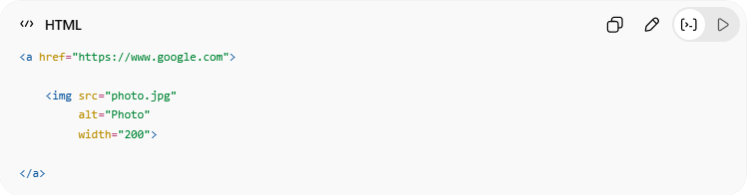
<a href="https://www.google.com">
<img src="photo.jpg"
alt="Photo"
width="200">
</a>

5. 🖼️ Animated Images (GIF)
# Source: AI Source: Provided by: [Data Path: Persons Table -> ID Column: 1, Name_En Column: Motasem Essam] -> From: [ChatGPT] on [5/6/2026]
📖 Description
GIF images can display animation.
💻 Example:
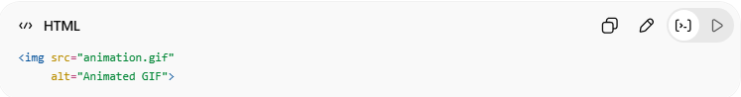
<img src="animation.gif"
alt="Animated GIF">

6. 📱 Responsive Images
# Source: AI Source: Provided by: [Data Path: Persons Table -> ID Column: 1, Name_En Column: Motasem Essam] -> From: [ChatGPT] on [5/6/2026]
📖 Description
Images can resize automatically for different screen sizes.
💻 Example:
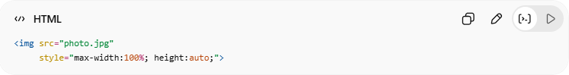
<img src="photo.jpg"
style="max-width:100%; height:auto;">

💻 Example

Full Example
# Source: AI Source: Provided by: [Data Path: Persons Table -> ID Column: 1, Name_En Column: Motasem Essam] -> From: [ChatGPT] on [5/6/2026]
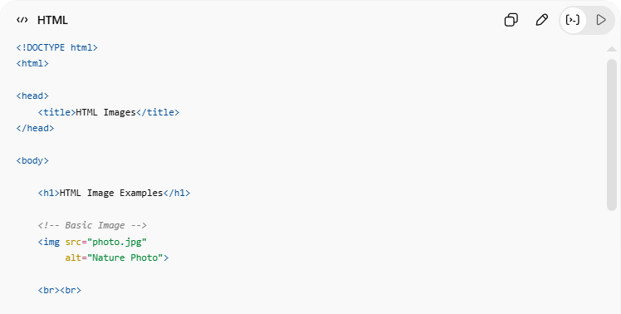
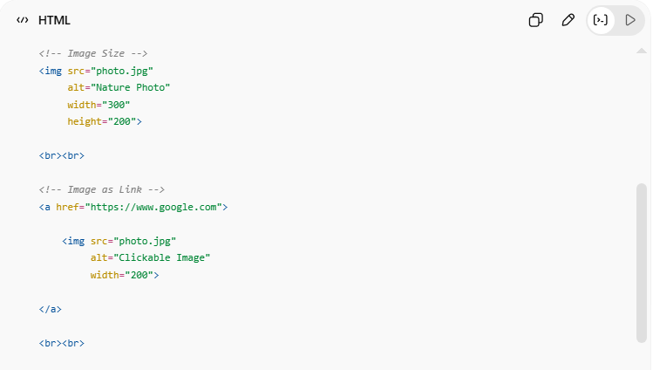
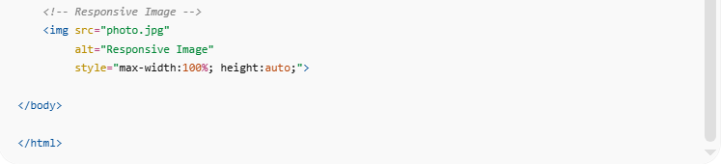
<!DOCTYPE html>
<html>
<head>
<title>HTML Images</title>
</head>
<body>
<h1>HTML Image Examples</h1>
<!-- Basic Image -->
<img src="photo.jpg"
alt="Nature Photo">
<br><br>
<!-- Image Size -->
<img src="photo.jpg"
alt="Nature Photo"
width="300"
height="200">
<br><br>
<!-- Image as Link -->
<a href="https://www.google.com">
<img src="photo.jpg"
alt="Clickable Image"
width="200">
</a>
<br><br>
<!-- Responsive Image -->
<img src="photo.jpg"
alt="Responsive Image"
style="max-width:100%; height:auto;">
</body>
</html>

Real Example
# Source: ScreenShot Source: Provided by: [Persons Table -> ID Column: 1, Name_En Column: Motasem Essam] -> Tool: [Automation Table -> ID Column: 16, Name_En Column: Screen Capture] -> From [Operating System: Windows] on [5/6/2026]
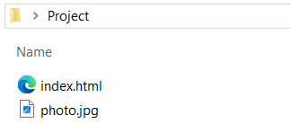
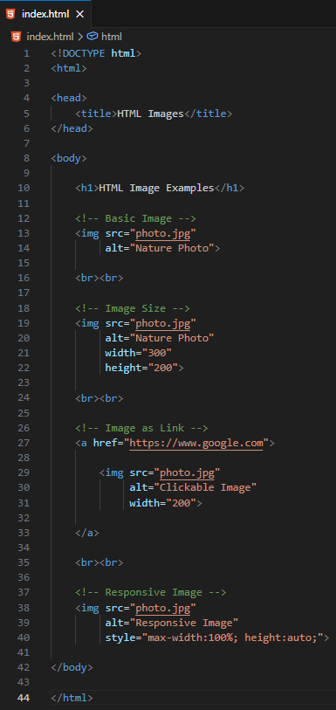
<!DOCTYPE html>
<html>

<head>
<title>HTML Images</title>
</head>

<body>

<h1>HTML Image Examples</h1>

<!-- Basic Image -->
<img src="photo.jpg"
alt="Nature Photo">

<br><br>

<!-- Image Size -->
<img src="photo.jpg"
alt="Nature Photo"
width="300"
height="200">

<br><br>

<!-- Image as Link -->
<a href="https://www.google.com">

<img src="photo.jpg"
alt="Clickable Image"
width="200">

</a>

<br><br>

<!-- Responsive Image -->
<img src="photo.jpg"
alt="Responsive Image"
style="max-width:100%; height:auto;">

</body>

</html>


⚠️ Important Notes

✅ Always Use alt
# Source: AI Source: Provided by: [Data Path: Persons Table -> ID Column: 1, Name_En Column: Motasem Essam] -> From: [ChatGPT] on [5/6/2026]
📖 Description
Improves accessibility and helps when image fails to load.
✅ Good Example:
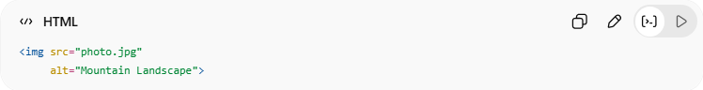
<img src="photo.jpg"
alt="Mountain Landscape">

❌ Avoid Missing alt
# Source: AI Source: Provided by: [Data Path: Persons Table -> ID Column: 1, Name_En Column: Motasem Essam] -> From: [ChatGPT] on [5/6/2026]
❌ Bad Example:
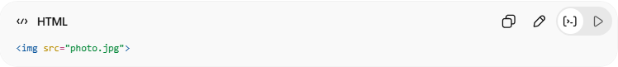
<img src="photo.jpg">

✅ <img> is a Void Element
# Source: AI Source: Provided by: [Data Path: Persons Table -> ID Column: 1, Name_En Column: Motasem Essam] -> From: [ChatGPT] on [5/6/2026]
👉 No closing tag needed
✅ Correct:
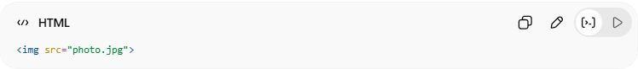
<img src="photo.jpg">

❌ Incorrect:
# Source: AI Source: Provided by: [Data Path: Persons Table -> ID Column: 1, Name_En Column: Motasem Essam] -> From: [ChatGPT] on [5/6/2026]
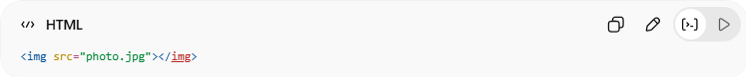
<img src="photo.jpg"></img>

📁 Images in Another Folder
# Source: AI Source: Provided by: [Data Path: Persons Table -> ID Column: 1, Name_En Column: Motasem Essam] -> From: [ChatGPT] on [5/6/2026]
You can load images from different folders using file paths.
HTML images can be loaded from the same folder, child folders, parent folders, nested folders, or online URLs using file paths.

📂 Image Inside Another Folder
# Source: AI Source: Provided by: [Data Path: Persons Table -> ID Column: 1, Name_En Column: Motasem Essam] -> From: [ChatGPT] on [5/6/2026]
💻 Example:
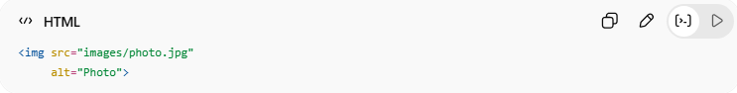
<img src="images/photo.jpg"
alt="Photo">
👉 The browser looks for:
images/photo.jpg

📂 Image Inside Nested Folder
# Source: AI Source: Provided by: [Data Path: Persons Table -> ID Column: 1, Name_En Column: Motasem Essam] -> From: [ChatGPT] on [5/6/2026]
💻 Example:
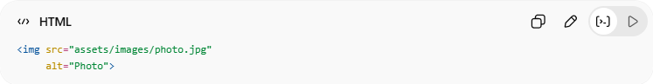
<img src="assets/images/photo.jpg"
alt="Photo">
👉 The browser looks for:
assets/images/photo.jpg

⬆️ Image from Parent Folder
# Source: AI Source: Provided by: [Data Path: Persons Table -> ID Column: 1, Name_En Column: Motasem Essam] -> From: [ChatGPT] on [5/6/2026]
📖 Description
Use ../ to move one folder up.
💻 Example:
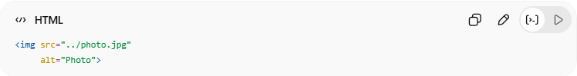
<img src="../photo.jpg"
alt="Photo">
👉 Goes one folder back

⬆️⬆️ Image from Two Parent Folders
# Source: AI Source: Provided by: [Data Path: Persons Table -> ID Column: 1, Name_En Column: Motasem Essam] -> From: [ChatGPT] on [5/6/2026]
💻 Example:
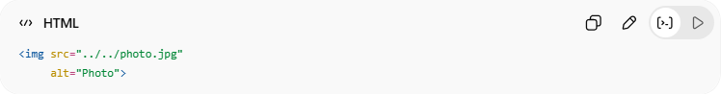
<img src="../../photo.jpg"
alt="Photo">
👉 Goes two folders back

🌐 Image from Website URL
💻 Example:
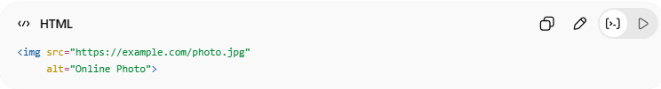
<img src="https://example.com/photo.jpg"
alt="Online Photo">
👉 Loads image directly from the internet

🧪 Common File Path Types
# Source: AI Source: Provided by: [Data Path: Persons Table -> ID Column: 1, Name_En Column: Motasem Essam] -> From: [ChatGPT] on [5/6/2026]
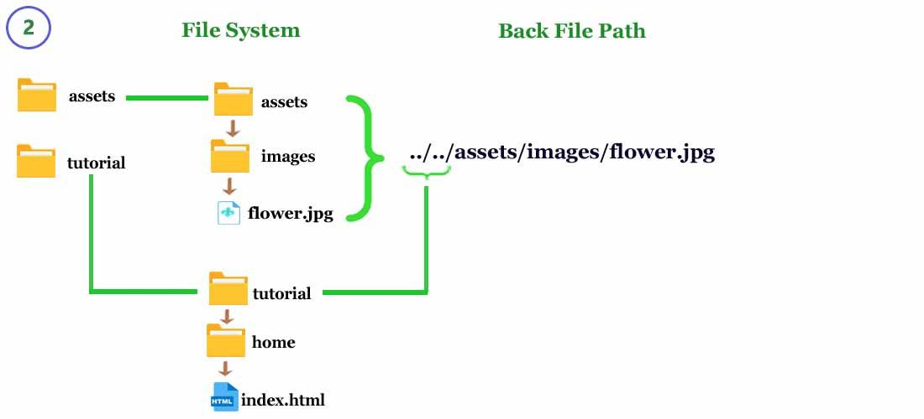
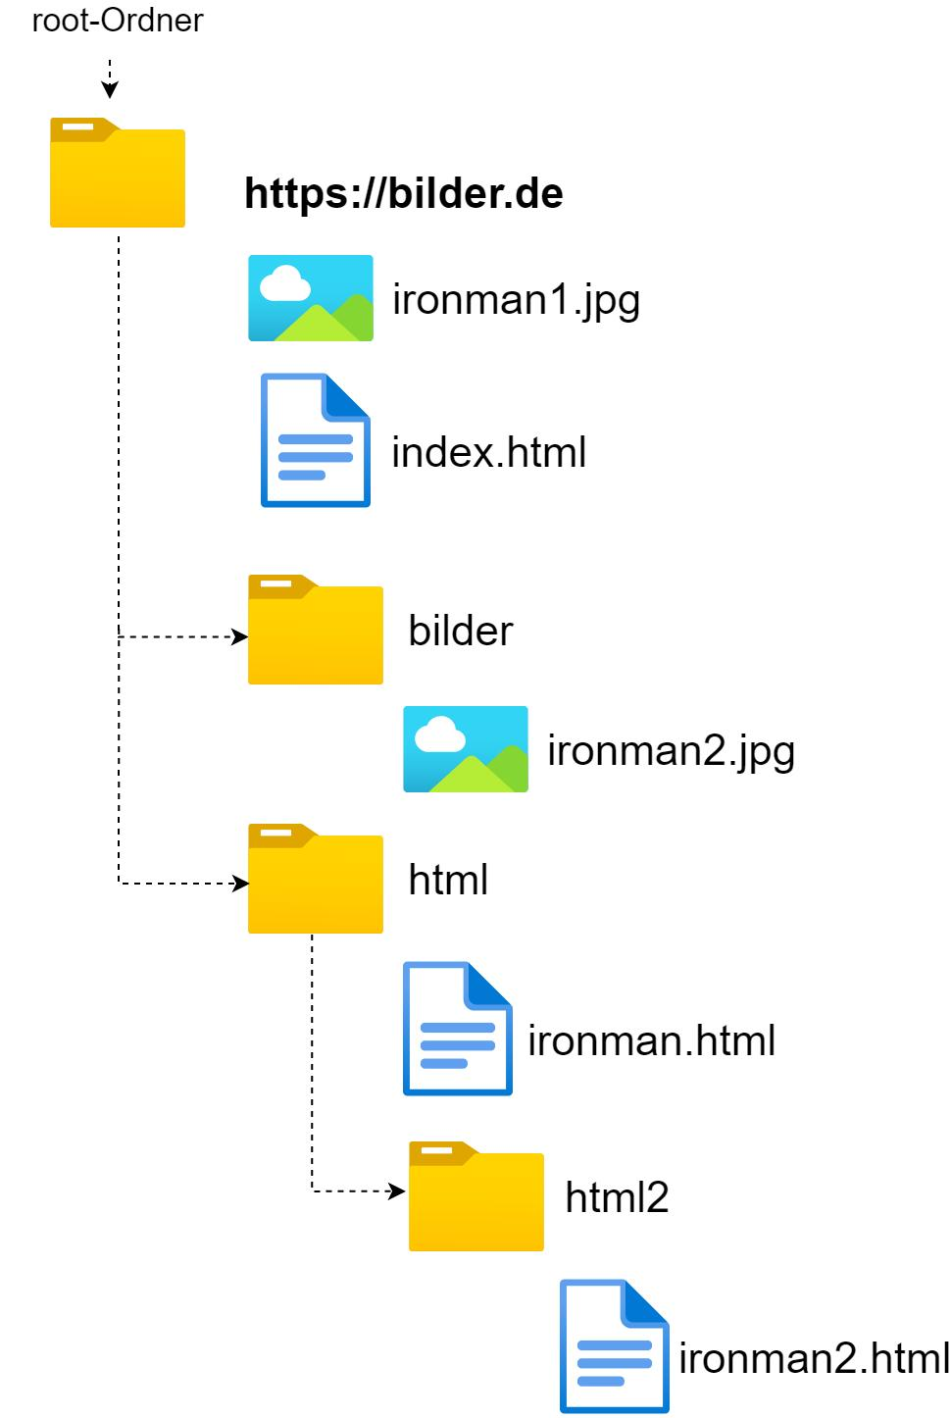
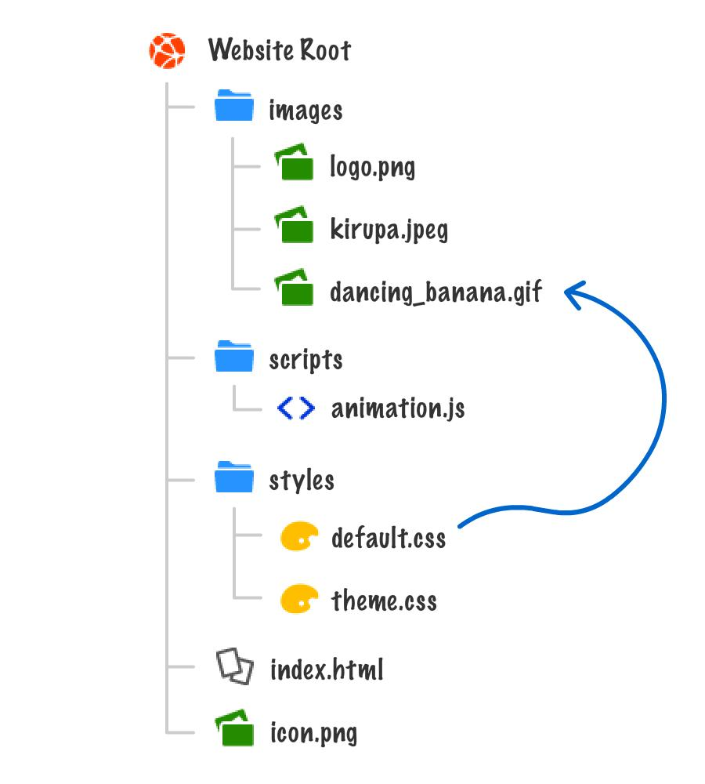
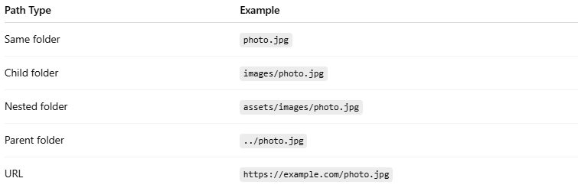
Path Type | Example
Same folder | photo.jpg
Child folder | images/photo.jpg
Nested folder | assets/images/photo.jpg
Parent folder | ../photo.jpg
URL | https://example.com/photo.jpg

🖼️ HTML Image Floating
# Source: AI Source: Provided by: [Data Path: Persons Table -> ID Column: 1, Name_En Column: Motasem Essam] -> From: [ChatGPT] on [5/6/2026]
Image floating allows text to wrap around an image using CSS float.
You can float images:
- left
- right

Image floating uses CSS float to position images left or right while text wraps around them.

🌊 Float Left
# Source: AI Source: Provided by: [Data Path: Persons Table -> ID Column: 1, Name_En Column: Motasem Essam] -> From: [ChatGPT] on [5/6/2026]
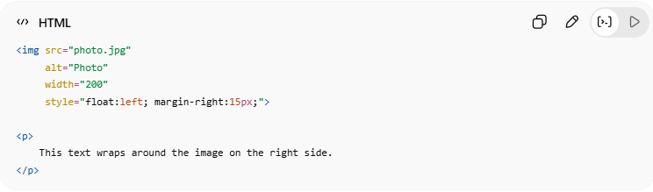
📖 Description
The image moves to the left and text wraps around it.
💻 Example:
<img src="photo.jpg"
alt="Photo"
width="200"
style="float:left; margin-right:15px;">
<p>
This text wraps around the image on the right side.
</p>

🌊 Float Right
# Source: AI Source: Provided by: [Data Path: Persons Table -> ID Column: 1, Name_En Column: Motasem Essam] -> From: [ChatGPT] on [5/6/2026]
📖 Description
The image moves to the right and text wraps around it.
💻 Example:
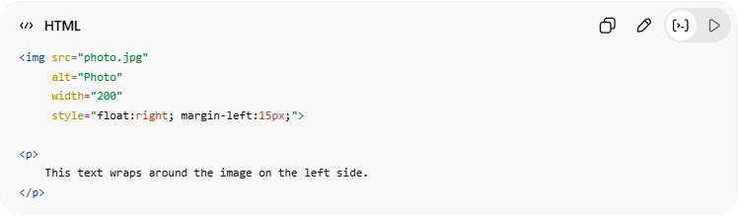
<img src="photo.jpg"
alt="Photo"
width="200"
style="float:right; margin-left:15px;">
<p>
This text wraps around the image on the left side.
</p>

💻 Example

Full Example
# Source: AI Source: Provided by: [Data Path: Persons Table -> ID Column: 1, Name_En Column: Motasem Essam] -> From: [ChatGPT] on [5/6/2026]
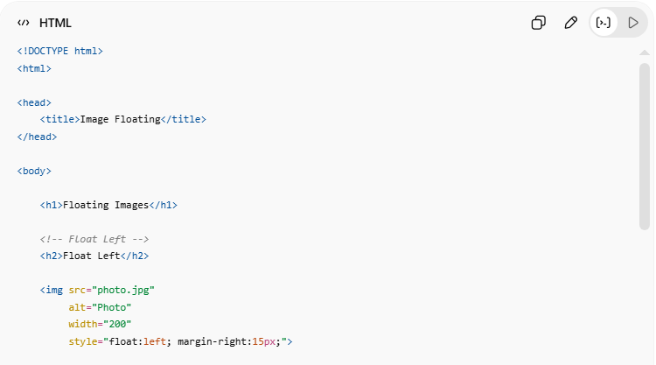
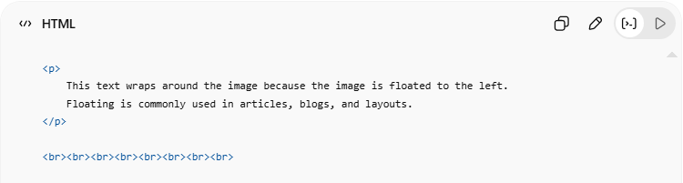
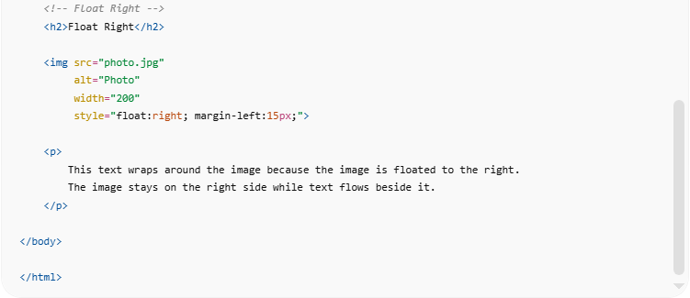
<!DOCTYPE html>
<html>

<head>
<title>Image Floating</title>
</head>

<body>

<h1>Floating Images</h1>

<!-- Float Left -->
<h2>Float Left</h2>

<img src="photo.jpg"
alt="Photo"
width="200"
style="float:left; margin-right:15px;">

<p>
This text wraps around the image because the image is floated to the left.
Floating is commonly used in articles, blogs, and layouts.
</p>

<br><br><br><br><br><br><br><br>

<!-- Float Right -->
<h2>Float Right</h2>

<img src="photo.jpg"
alt="Photo"
width="200"
style="float:right; margin-left:15px;">

<p>
This text wraps around the image because the image is floated to the right.
The image stays on the right side while text flows beside it.
</p>

</body>

</html>

Real Example
# Source: ScreenShot Source: Provided by: [Persons Table -> ID Column: 1, Name_En Column: Motasem Essam] -> Tool: [Automation Table -> ID Column: 16, Name_En Column: Screen Capture] -> From [Operating System: Windows] on [5/6/2026]
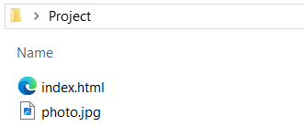
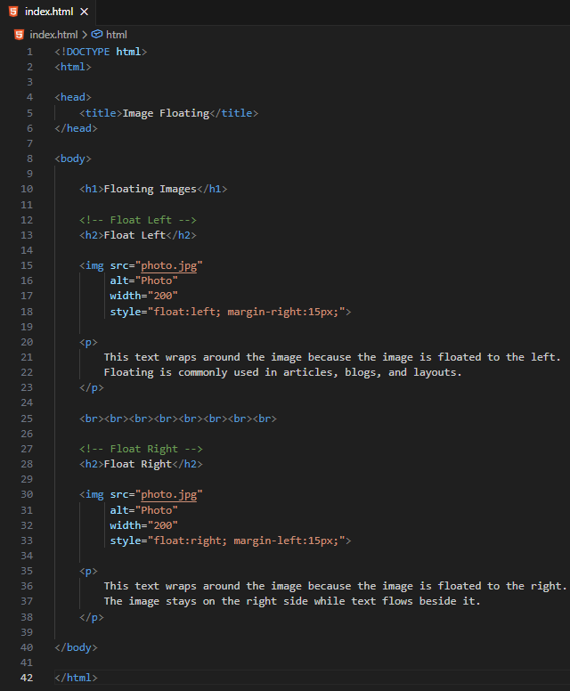
<!DOCTYPE html>
<html>

<head>
<title>Image Floating</title>
</head>

<body>

<h1>Floating Images</h1>

<!-- Float Left -->
<h2>Float Left</h2>

<img src="photo.jpg"
alt="Photo"
width="200"
style="float:left; margin-right:15px;">

<p>
This text wraps around the image because the image is floated to the left.
Floating is commonly used in articles, blogs, and layouts.
</p>

<br><br><br><br><br><br><br><br>

<!-- Float Right -->
<h2>Float Right</h2>

<img src="photo.jpg"
alt="Photo"
width="200"
style="float:right; margin-left:15px;">

<p>
This text wraps around the image because the image is floated to the right.
The image stays on the right side while text flows beside it.
</p>

</body>

</html>
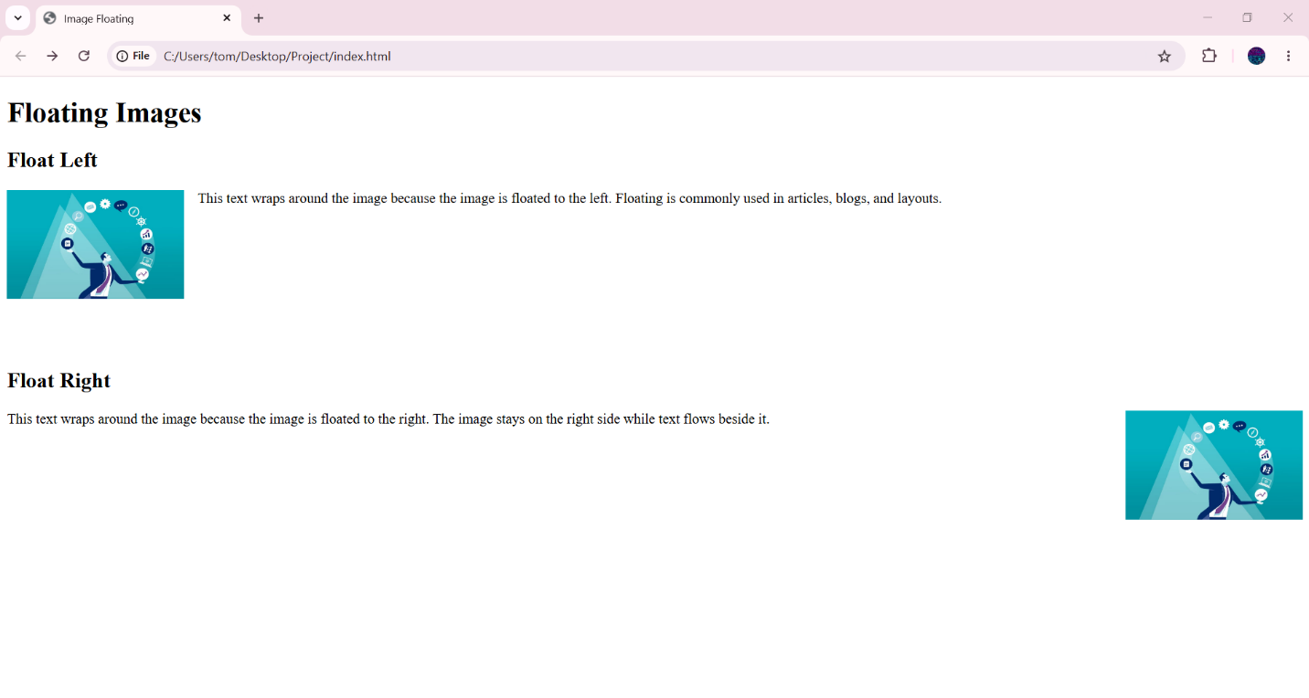

🧪 What You Can Test
# Source: AI Source: Provided by: [Data Path: Persons Table -> ID Column: 1, Name_En Column: Motasem Essam] -> From: [ChatGPT] on [5/6/2026]

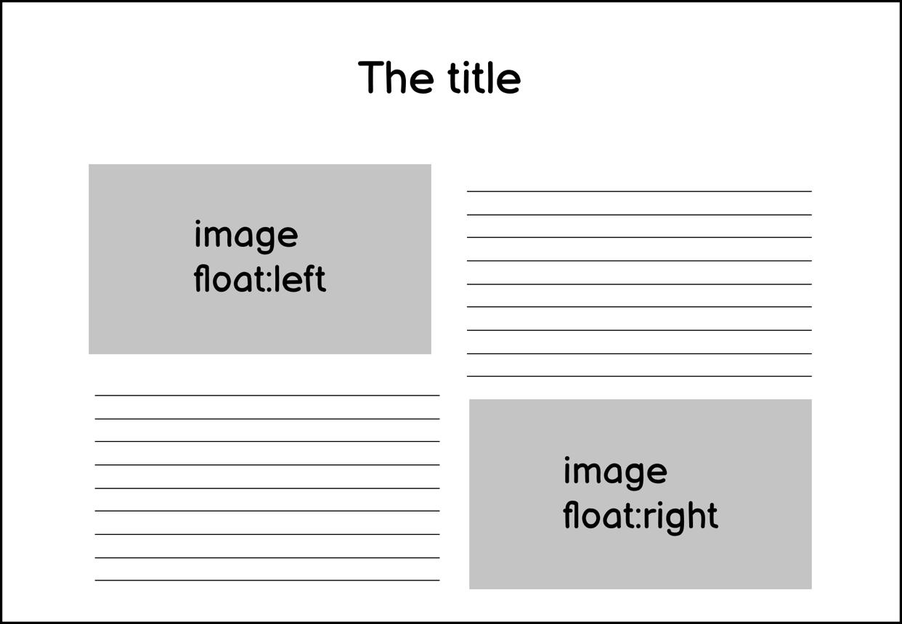
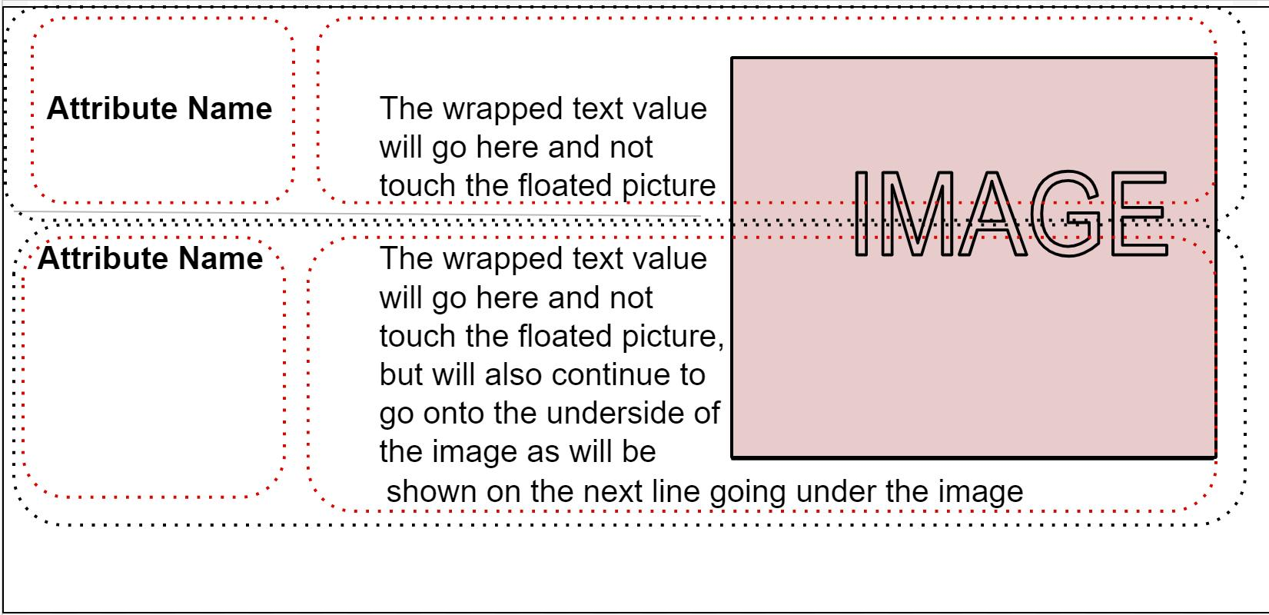
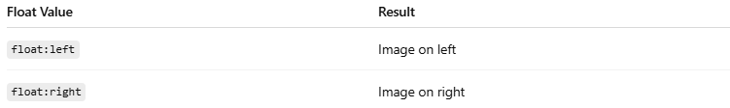
Float Value | Result
float:left | Image on left
float:right | Image on right

⚠️ Important Notes

✅ Use Margin with Floating
# Source: AI Source: Provided by: [Data Path: Persons Table -> ID Column: 1, Name_En Column: Motasem Essam] -> From: [ChatGPT] on [5/6/2026]
📖 Description
Margins add space between text and image.
💻 Example:
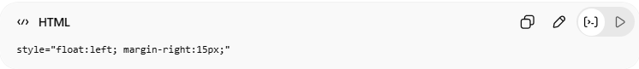
style="float:left; margin-right:15px;"

❌ Without Margin
# Source: AI Source: Provided by: [Data Path: Persons Table -> ID Column: 1, Name_En Column: Motasem Essam] -> From: [ChatGPT] on [5/6/2026]
👉 Text may stick directly to the image

🗺️ HTML Image Maps
# Source: AI Source: Provided by: [Data Path: Persons Table -> ID Column: 1, Name_En Column: Motasem Essam] -> From: [ChatGPT] on [5/6/2026]
HTML image maps create multiple clickable regions inside one image using <map> and <area>.
HTML image maps allow different areas of a single image to become clickable links.
You can create clickable:
- rectangles
- circles
- polygons
using:
- <map>
- <area>

🧠 Main Elements
# Source: AI Source: Provided by: [Data Path: Persons Table -> ID Column: 1, Name_En Column: Motasem Essam] -> From: [ChatGPT] on [5/6/2026]
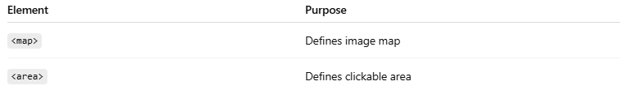
Element | Purpose
<map> | Defines image map
<area> | Defines clickable area

🌐 Basic Structure
# Source: AI Source: Provided by: [Data Path: Persons Table -> ID Column: 1, Name_En Column: Motasem Essam] -> From: [ChatGPT] on [5/6/2026]
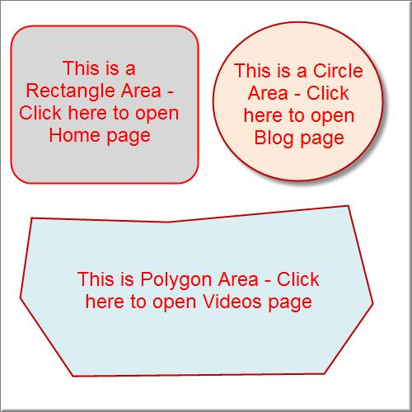
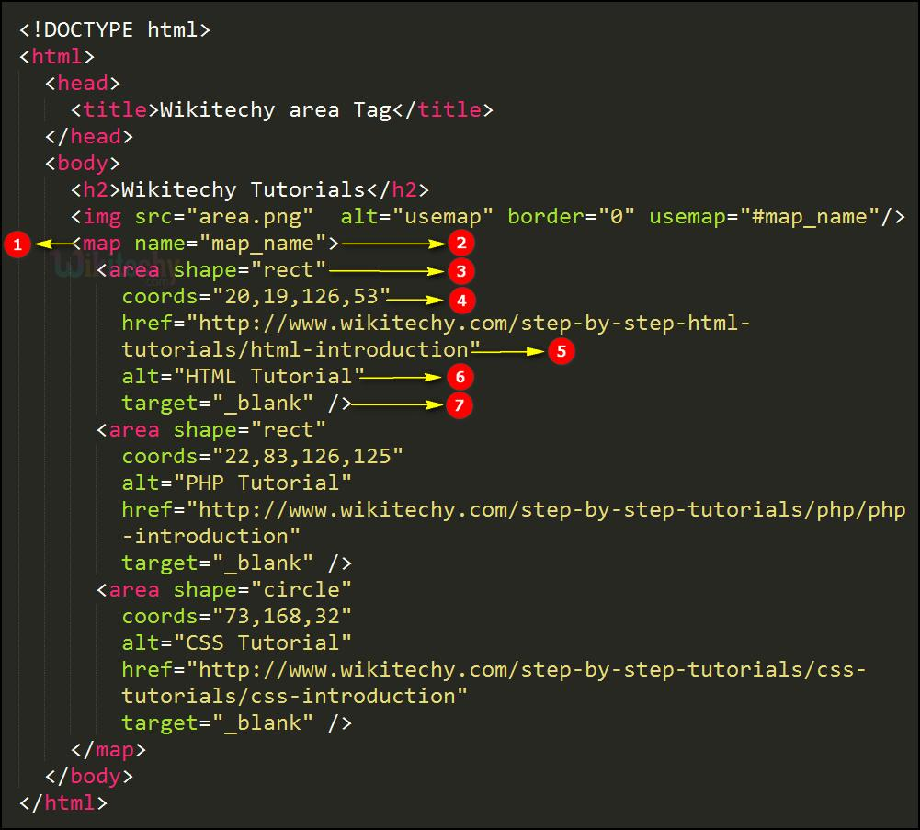
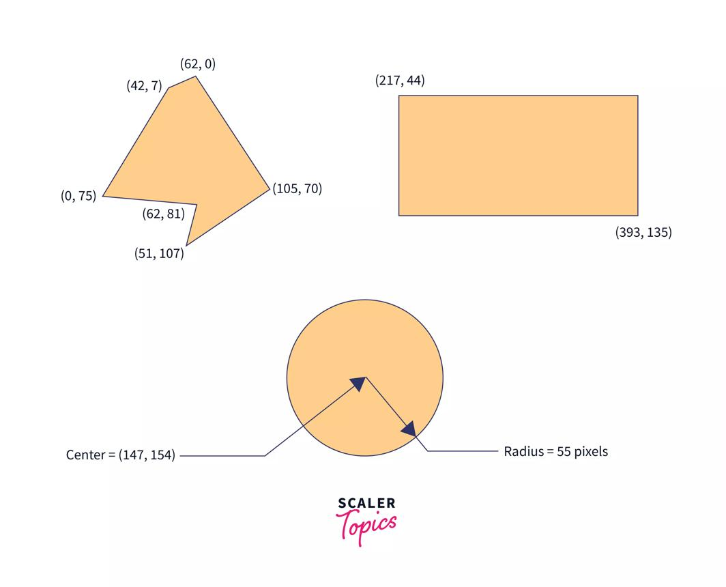
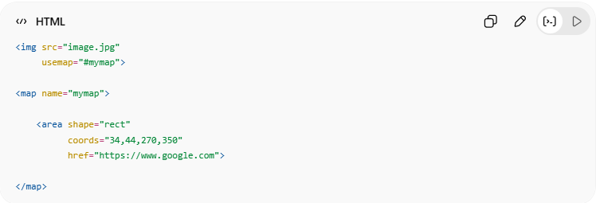
<img src="image.jpg"
usemap="#mymap">
<map name="mymap">
<area shape="rect"
coords="34,44,270,350"
href="https://www.google.com">
</map>
👉 Different image areas become clickable

🔤 Common shape Values
# Source: AI Source: Provided by: [Data Path: Persons Table -> ID Column: 1, Name_En Column: Motasem Essam] -> From: [ChatGPT] on [5/6/2026]
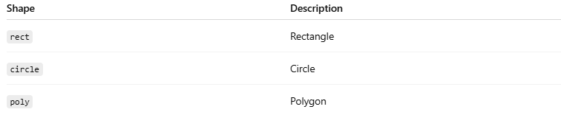
Shape | Description
rect | Rectangle
circle | Circle
poly | Polygon

1. ⬛ Rectangle Area (rect)
# Source: AI Source: Provided by: [Data Path: Persons Table -> ID Column: 1, Name_En Column: Motasem Essam] -> From: [ChatGPT] on [5/6/2026]
📖 Description
Creates a rectangular clickable area.
💻 Example:
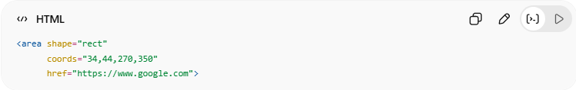
<area shape="rect"
coords="34,44,270,350"
href="https://www.google.com">
👉 Coordinates:
left,top,right,bottom

2. 🔵 Circle Area (circle)
# Source: AI Source: Provided by: [Data Path: Persons Table -> ID Column: 1, Name_En Column: Motasem Essam] -> From: [ChatGPT] on [5/6/2026]
📖 Description
Creates a circular clickable area.
💻 Example:
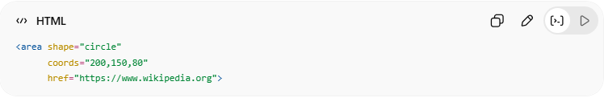
<area shape="circle"
coords="200,150,80"
href="https://www.wikipedia.org">
👉 Coordinates:
centerX,centerY,radius

3. 🔺 Polygon Area (poly)
# Source: AI Source: Provided by: [Data Path: Persons Table -> ID Column: 1, Name_En Column: Motasem Essam] -> From: [ChatGPT] on [5/6/2026]
📖 Description
Creates a custom polygon shape.
💻 Example:
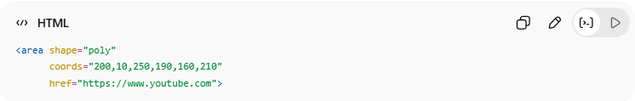
<area shape="poly"
coords="200,10,250,190,160,210"
href="https://www.youtube.com">
👉 Multiple coordinate points define the shape

💻 Example

Full Example
# Source: AI Source: Provided by: [Data Path: Persons Table -> ID Column: 1, Name_En Column: Motasem Essam] -> From: [ChatGPT] on [5/6/2026]
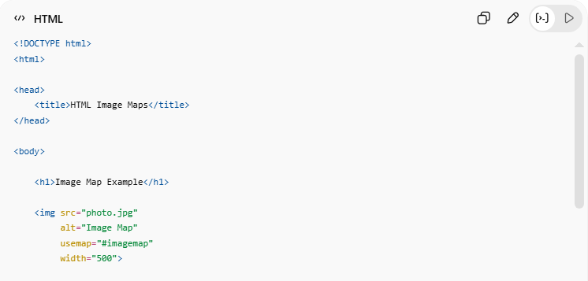
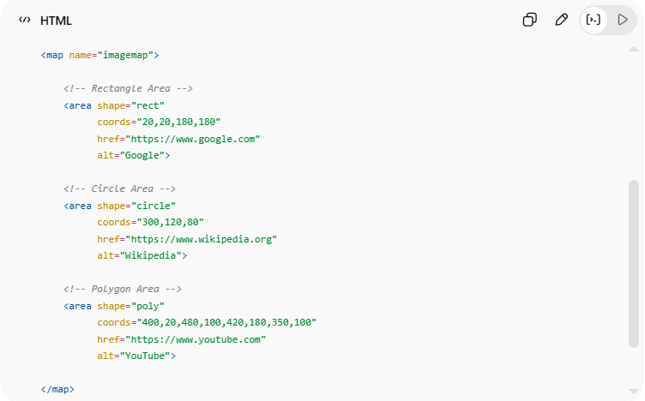
<!DOCTYPE html>
<html>
<head>
<title>HTML Image Maps</title>
</head>
<body>
<h1>Image Map Example</h1>
<img src="photo.jpg"
alt="Image Map"
usemap="#imagemap"
width="500">
<map name="imagemap">
<!-- Rectangle Area -->
<area shape="rect"
coords="20,20,180,180"
href="https://www.google.com"
alt="Google">
<!-- Circle Area -->
<area shape="circle"
coords="300,120,80"
href="https://www.wikipedia.org"
alt="Wikipedia">
<!-- Polygon Area -->
<area shape="poly"
coords="400,20,480,100,420,180,350,100"
href="https://www.youtube.com"
alt="YouTube">
</map>
</body>
</html>

Real Example
# Source: ScreenShot Source: Provided by: [Persons Table -> ID Column: 1, Name_En Column: Motasem Essam] -> Tool: [Automation Table -> ID Column: 16, Name_En Column: Screen Capture] -> From [Operating System: Windows] on [5/6/2026]
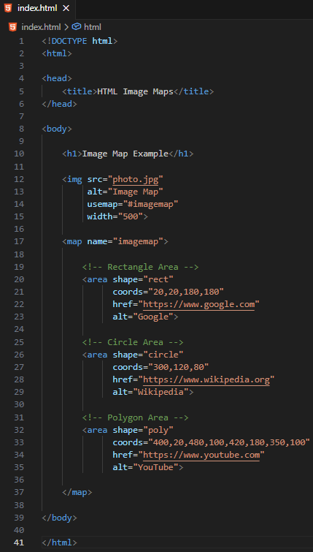
<!DOCTYPE html>
<html>

<head>
<title>HTML Image Maps</title>
</head>

<body>

<h1>Image Map Example</h1>

<img src="photo.jpg"
alt="Image Map"
usemap="#imagemap"
width="500">

<map name="imagemap">

<!-- Rectangle Area -->
<area shape="rect"
coords="20,20,180,180"
href="https://www.google.com"
alt="Google">

<!-- Circle Area -->
<area shape="circle"
coords="300,120,80"
href="https://www.wikipedia.org"
alt="Wikipedia">

<!-- Polygon Area -->
<area shape="poly"
coords="400,20,480,100,420,180,350,100"
href="https://www.youtube.com"
alt="YouTube">

</map>

</body>

</html>


🧪 What You Can Test
# Source: AI Source: Provided by: [Data Path: Persons Table -> ID Column: 1, Name_En Column: Motasem Essam] -> From: [ChatGPT] on [5/6/2026]


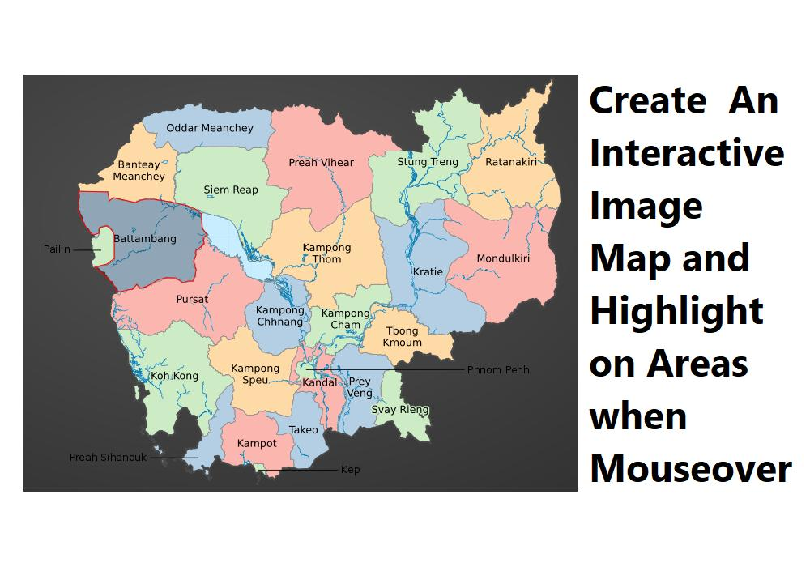
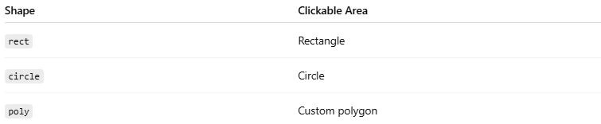
Shape | Clickable Area
rect | Rectangle
circle | Circle
poly | Custom polygon

⚠️ Important Notes

✅ usemap connects image to map
# Source: AI Source: Provided by: [Data Path: Persons Table -> ID Column: 1, Name_En Column: Motasem Essam] -> From: [ChatGPT] on [5/6/2026]
💻 Example:
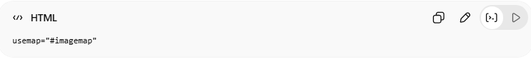
usemap="#imagemap"
👉 Must match:
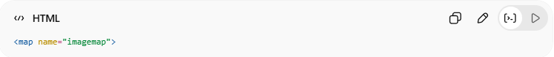
<map name="imagemap">

✅ Always Use alt
# Source: AI Source: Provided by: [Data Path: Persons Table -> ID Column: 1, Name_En Column: Motasem Essam] -> From: [ChatGPT] on [5/6/2026]
📖 Description
Improves accessibility.

❌ Coordinates are pixel-based
# Source: AI Source: Provided by: [Data Path: Persons Table -> ID Column: 1, Name_En Column: Motasem Essam] -> From: [ChatGPT] on [5/6/2026]
👉 Incorrect coordinates may create wrong clickable areas

🖼️ HTML Background Images
# Source: AI Source: Provided by: [Data Path: Persons Table -> ID Column: 1, Name_En Column: Motasem Essam] -> From: [ChatGPT] on [5/6/2026]
HTML background images are added using CSS and can style webpages or elements with customizable size, position, repeat, and scrolling behavior.
Background images are images placed behind HTML elements using CSS.
They can be added to:
- the whole webpage
- specific elements
- sections
- divs

🌐 Basic Background Image
# Source: AI Source: Provided by: [Data Path: Persons Table -> ID Column: 1, Name_En Column: Motasem Essam] -> From: [ChatGPT] on [5/6/2026]
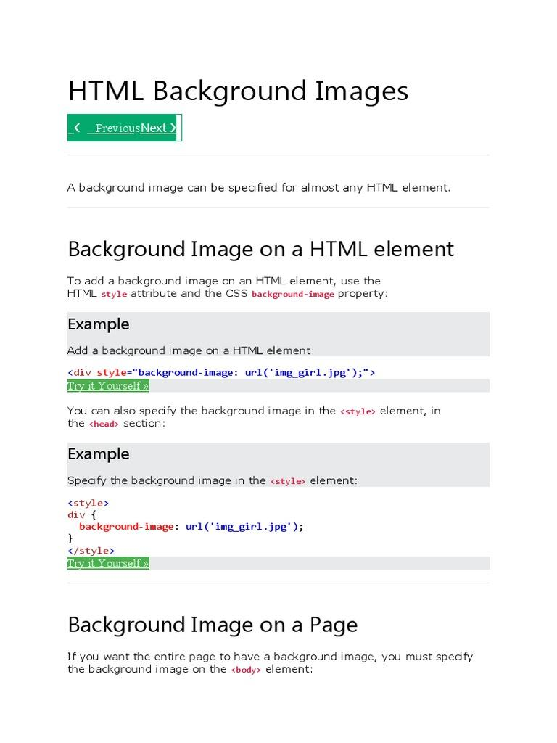
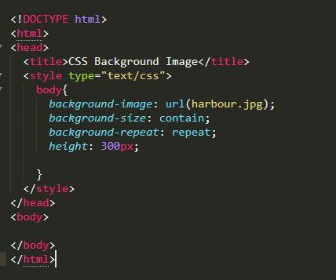
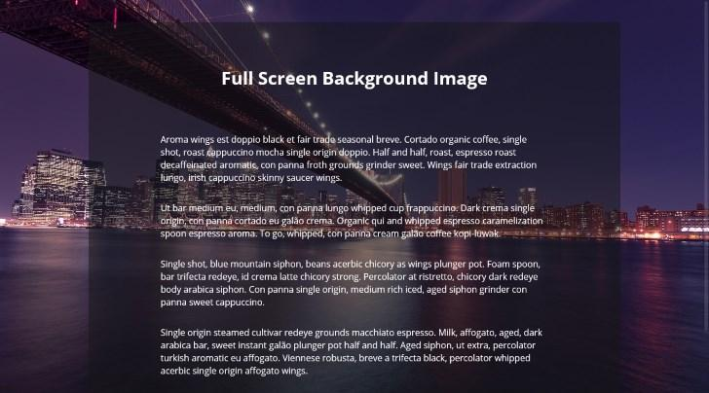
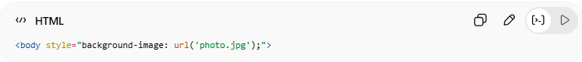
<body style="background-image: url('photo.jpg');">
👉 Sets an image as webpage background

🔤 Common Background Image Features
# Source: AI Source: Provided by: [Data Path: Persons Table -> ID Column: 1, Name_En Column: Motasem Essam] -> From: [ChatGPT] on [5/6/2026]
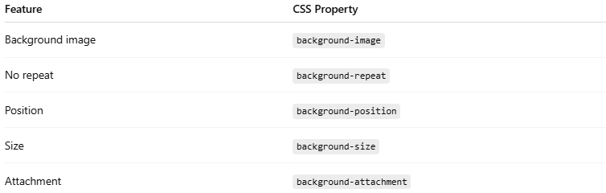
Feature | CSS Property
Background image | background-image
No repeat | background-repeat
Position | background-position
Size | background-size
Attachment | background-attachment

1. 🖼️ Background Image for Whole Page
# Source: AI Source: Provided by: [Data Path: Persons Table -> ID Column: 1, Name_En Column: Motasem Essam] -> From: [ChatGPT] on [5/6/2026]33
📖 Description
Adds background image to the entire webpage.
💻 Example:
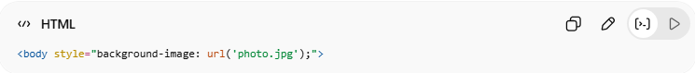
<body style="background-image: url('photo.jpg');">

2. 🚫 No Repeat
# Source: AI Source: Provided by: [Data Path: Persons Table -> ID Column: 1, Name_En Column: Motasem Essam] -> From: [ChatGPT] on [5/6/2026]
📖 Description
Prevents repeating the image.
💻 Example:
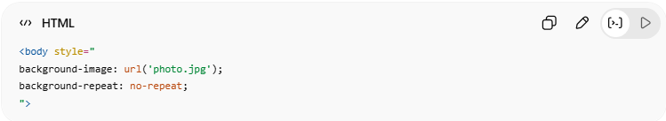
<body style="
background-image: url('photo.jpg');
background-repeat: no-repeat;
">

3. 📍 Background Position
# Source: AI Source: Provided by: [Data Path: Persons Table -> ID Column: 1, Name_En Column: Motasem Essam] -> From: [ChatGPT] on [5/6/2026]
📖 Description
Controls image placement.
💻 Example:
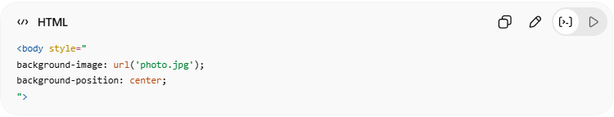
<body style="
background-image: url('photo.jpg');
background-position: center;
">

4. 📏 Background Size
# Source: AI Source: Provided by: [Data Path: Persons Table -> ID Column: 1, Name_En Column: Motasem Essam] -> From: [ChatGPT] on [5/6/2026]
📖 Description
Controls image size.
💻 Example:
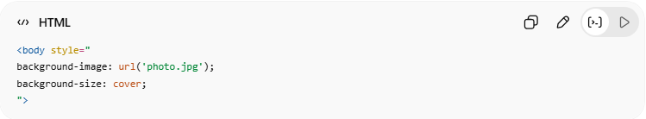
<body style="
background-image: url('photo.jpg');
background-size: cover;
">
👉 cover fills entire area

5. 📌 Fixed Background
# Source: AI Source: Provided by: [Data Path: Persons Table -> ID Column: 1, Name_En Column: Motasem Essam] -> From: [ChatGPT] on [5/6/2026]
📖 Description
Background stays fixed during scrolling.
💻 Example:
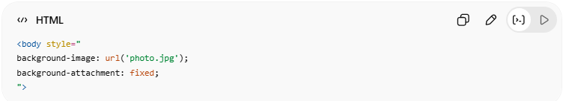
<body style="
background-image: url('photo.jpg');
background-attachment: fixed;
">

6. 🧩 Background Image for Specific Element
# Source: AI Source: Provided by: [Data Path: Persons Table -> ID Column: 1, Name_En Column: Motasem Essam] -> From: [ChatGPT] on [5/6/2026]
📖 Description
Background image can be applied to a single element.
💻 Example:
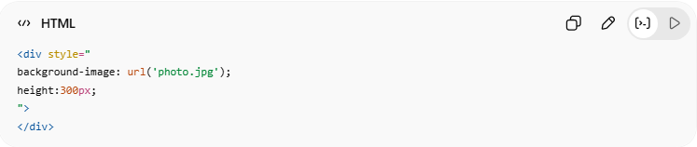
<div style="
background-image: url('photo.jpg');
height:300px;
">
</div>

7. 🖼️ Background Cover
# Source: AI Source: Provided by: [Data Path: Persons Table -> ID Column: 1, Name_En Column: Motasem Essam] -> From: [ChatGPT] on [5/6/2026]
📖 Description
background-size: cover makes the background image fully cover the entire element or webpage while keeping the image proportions.
👉 The image may be cropped to fit properly.
💻 Example:
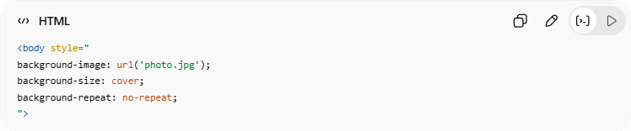
<body style="
background-image: url('photo.jpg');
background-size: cover;
background-repeat: no-repeat;
">

8. ➕ Background Stretch
# Source: AI Source: Provided by: [Data Path: Persons Table -> ID Column: 1, Name_En Column: Motasem Essam] -> From: [ChatGPT] on [5/6/2026]
📖 Description
background-size: 100% 100% stretches the background image to fully fit the width and height of the element.
👉 The image may become distorted because the original proportions are not preserved.
💻 Example:
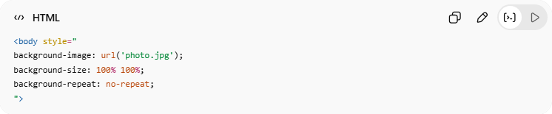
<body style="
background-image: url('photo.jpg');
background-size: 100% 100%;
background-repeat: no-repeat;
">

💻 Example

Full Example
# Source: AI Source: Provided by: [Data Path: Persons Table -> ID Column: 1, Name_En Column: Motasem Essam] -> From: [ChatGPT] on [5/6/2026]
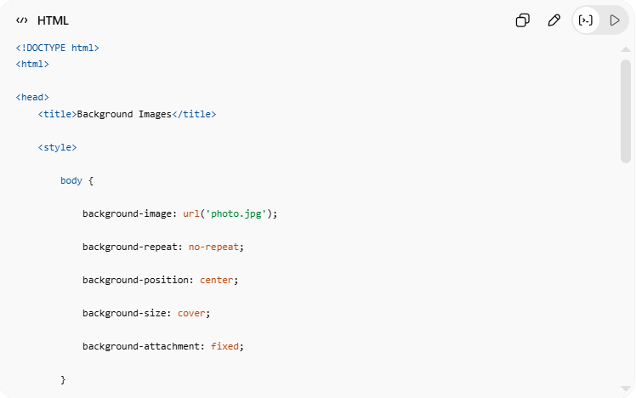
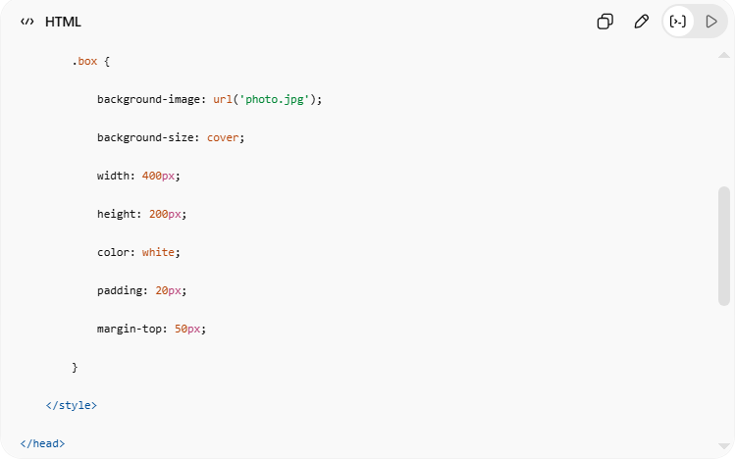
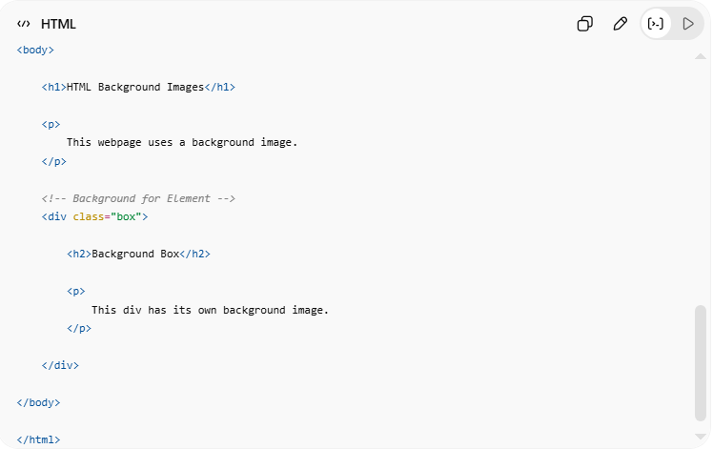
<!DOCTYPE html>
<html>
<head>
<title>Background Images</title>
<style>
body {
background-image: url('photo.jpg');
background-repeat: no-repeat;
background-position: center;
background-size: cover;
background-attachment: fixed;
}
.box {
background-image: url('photo.jpg');
background-size: cover;
width: 400px;
height: 200px;
color: white;
padding: 20px;
margin-top: 50px;
}
</style>
</head>
<body>
<h1>HTML Background Images</h1>
<p>
This webpage uses a background image.
</p>
<!-- Background for Element -->
<div class="box">
<h2>Background Box</h2>
<p>
This div has its own background image.
</p>
</div>
</body>
</html>

Real Example
# Source: ScreenShot Source: Provided by: [Persons Table -> ID Column: 1, Name_En Column: Motasem Essam] -> Tool: [Automation Table -> ID Column: 16, Name_En Column: Screen Capture] -> From [Operating System: Windows] on [5/6/2026]
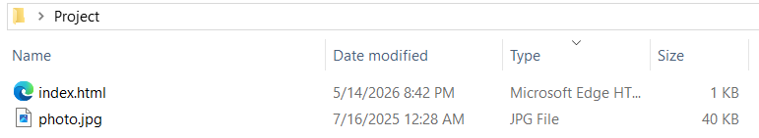
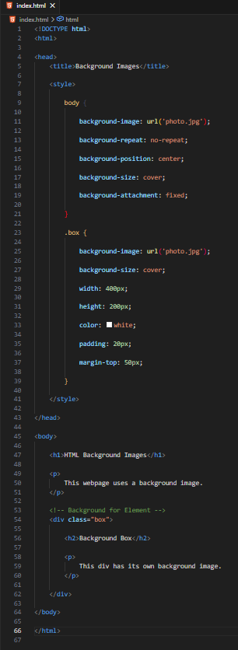
<!DOCTYPE html>
<html>

<head>
<title>Background Images</title>

<style>

body {

background-image: url('photo.jpg');

background-repeat: no-repeat;

background-position: center;

background-size: cover;

background-attachment: fixed;

}

.box {

background-image: url('photo.jpg');

background-size: cover;

width: 400px;

height: 200px;

color: white;

padding: 20px;

margin-top: 50px;

}

</style>

</head>

<body>

<h1>HTML Background Images</h1>

<p>
This webpage uses a background image.
</p>

<!-- Background for Element -->
<div class="box">

<h2>Background Box</h2>

<p>
This div has its own background image.
</p>

</div>

</body>

</html>
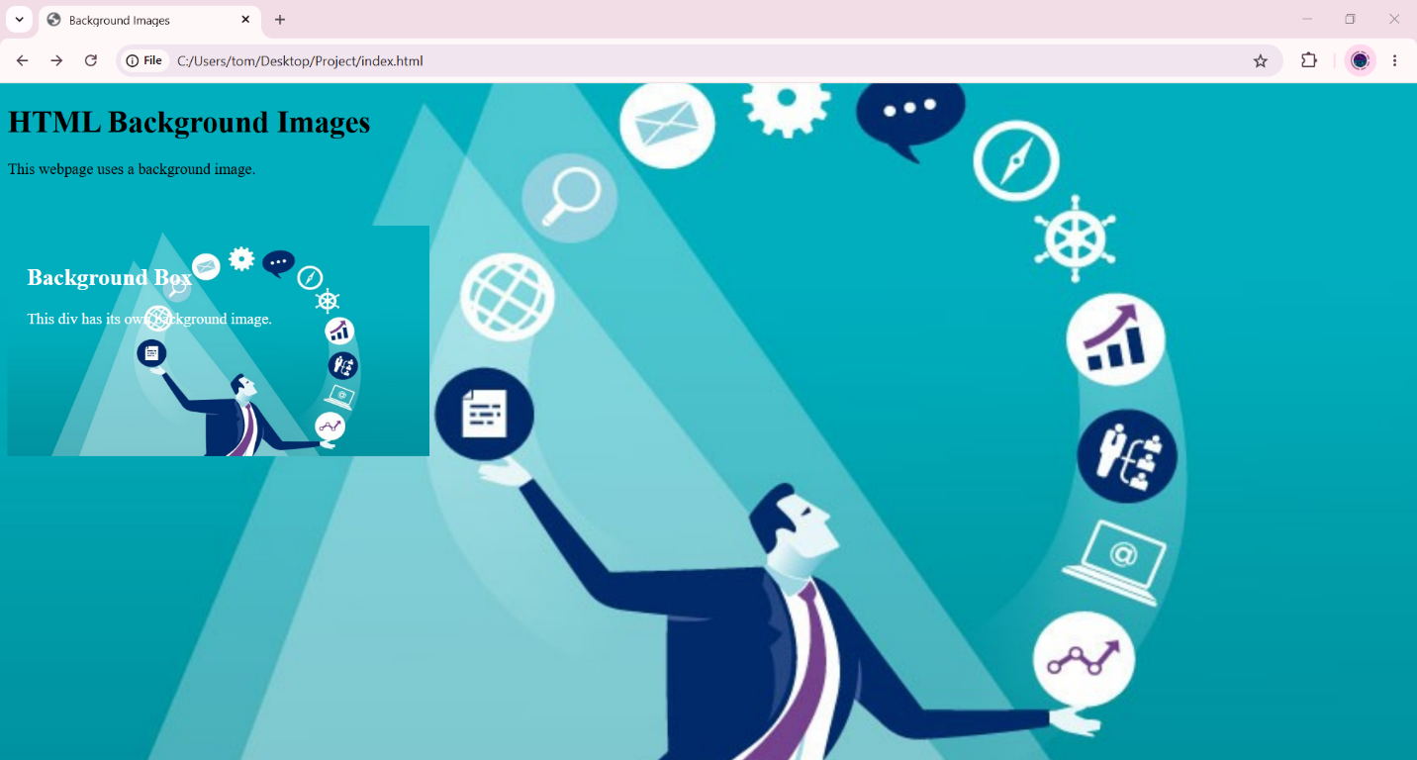

🧪 What You Can Test
# Source: AI Source: Provided by: [Data Path: Persons Table -> ID Column: 1, Name_En Column: Motasem Essam] -> From: [ChatGPT] on [5/6/2026]
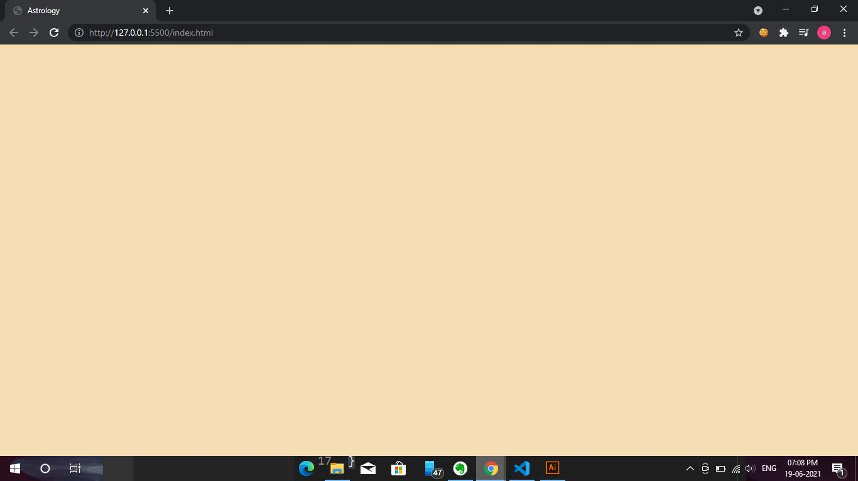

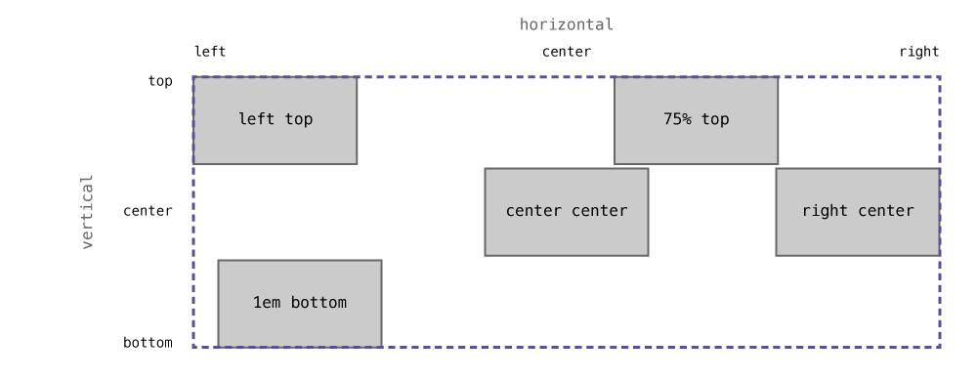
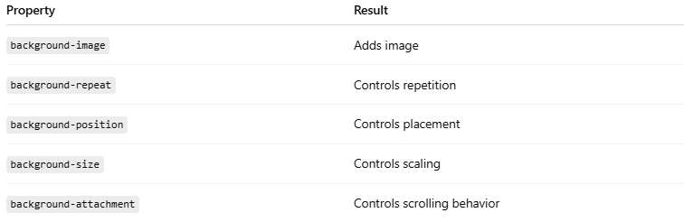
Property | Result
background-image | Adds image
background-repeat | Controls repetition
background-position | Controls placement
background-size | Controls scaling
background-attachment | Controls scrolling behavior

📍 background-position Values
# Source: AI Source: Provided by: [Data Path: Persons Table -> ID Column: 1, Name_En Column: Motasem Essam] -> From: [ChatGPT] on [5/6/2026]
Controls where the background image appears inside the element.
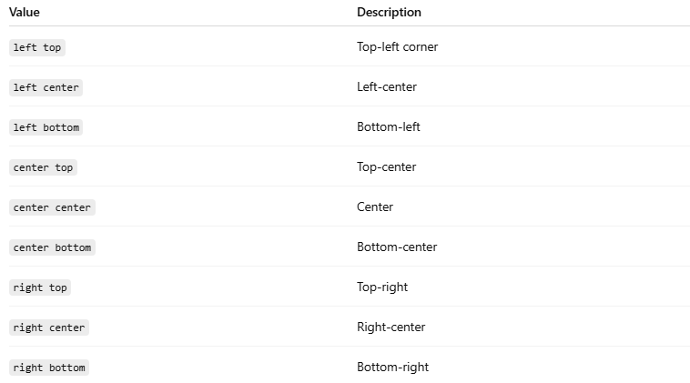
Value | Description
left top | Top-left corner
left center | Left-center
left bottom | Bottom-left
center top | Top-center
center center | Center
center bottom | Bottom-center
right top | Top-right
right center | Right-center
right bottom | Bottom-right
💻 Example
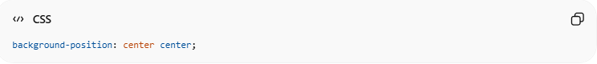
background-position: center center;

📏background-size Values
Controls the size of the background image.
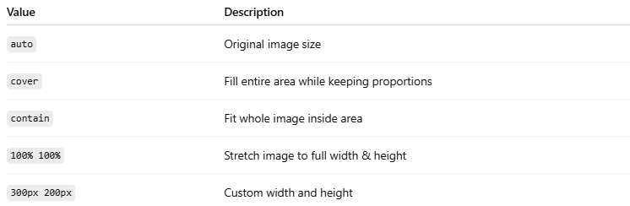
Value | Description
auto | Original image size
cover | Fill entire area while keeping proportions
contain | Fit whole image inside area
100% 100% | Stretch image to full width & height
300px 200px | Custom width and height

💻 Examples
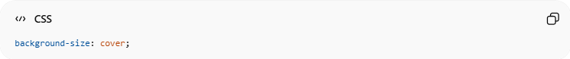
background-size: cover;

🔁 background-repeat Values
# Source: AI Source: Provided by: [Data Path: Persons Table -> ID Column: 1, Name_En Column: Motasem Essam] -> From: [ChatGPT] on [5/6/2026]
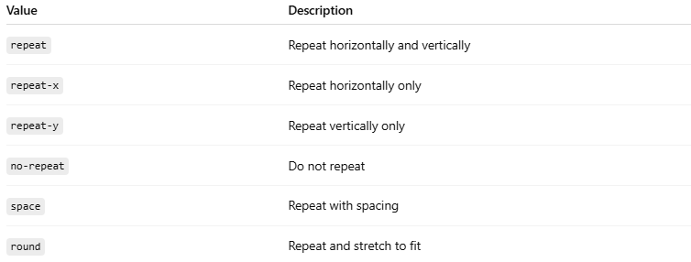
Value | Description
repeat | Repeat horizontally and vertically
repeat-x | Repeat horizontally only
repeat-y | Repeat vertically only
no-repeat | Do not repeat
space | Repeat with spacing
round | Repeat and stretch to fit
💻 Examples
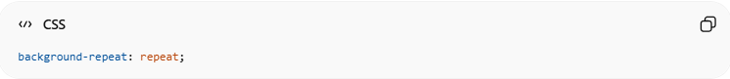
background-repeat: repeat;

⚠️ Important Notes

✅ Use background-size: cover
# Source: AI Source: Provided by: [Data Path: Persons Table -> ID Column: 1, Name_En Column: Motasem Essam] -> From: [ChatGPT] on [5/6/2026]
👉 Makes image fill the area properly

✅ Use readable text colors
# Source: AI Source: Provided by: [Data Path: Persons Table -> ID Column: 1, Name_En Column: Motasem Essam] -> From: [ChatGPT] on [5/6/2026]
👉 Background images may reduce readability

❌ Avoid very large images
# Source: AI Source: Provided by: [Data Path: Persons Table -> ID Column: 1, Name_En Column: Motasem Essam] -> From: [ChatGPT] on [5/6/2026]
👉 Large images slow webpage loading

🖼️ HTML picture Element
# Source: AI Source: Provided by: [Data Path: Persons Table -> ID Column: 1, Name_En Column: Motasem Essam] -> From: [ChatGPT] on [5/6/2026]
The HTML <picture> element allows responsive and optimized images by providing multiple image sources for different devices and formats.
The HTML <picture> element is used to display different images depending on:
- screen size
- device type
- image format
It helps create:
- responsive images
- optimized images
- modern web performance

🧠 Main Elements Used
# Source: AI Source: Provided by: [Data Path: Persons Table -> ID Column: 1, Name_En Column: Motasem Essam] -> From: [ChatGPT] on [5/6/2026]
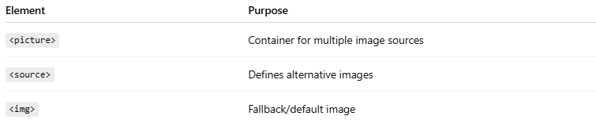
Element | Purpose
<picture> | Container for multiple image sources
<source> | Defines alternative images
<img> | Fallback/default image

🌐 Basic Structure
# Source: AI Source: Provided by: [Data Path: Persons Table -> ID Column: 1, Name_En Column: Motasem Essam] -> From: [ChatGPT] on [5/6/2026]
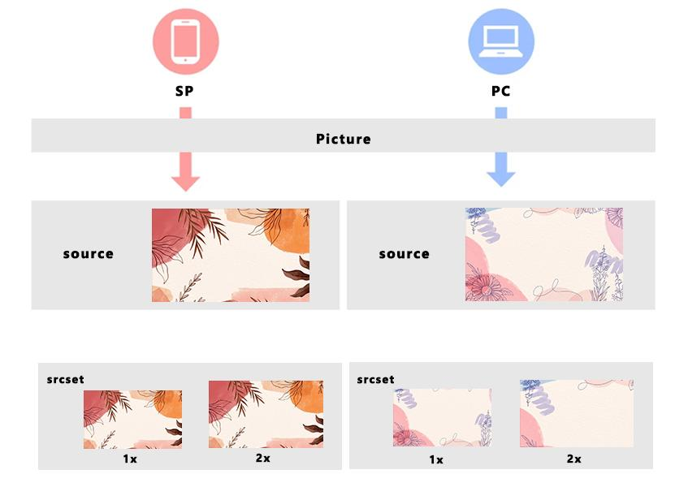
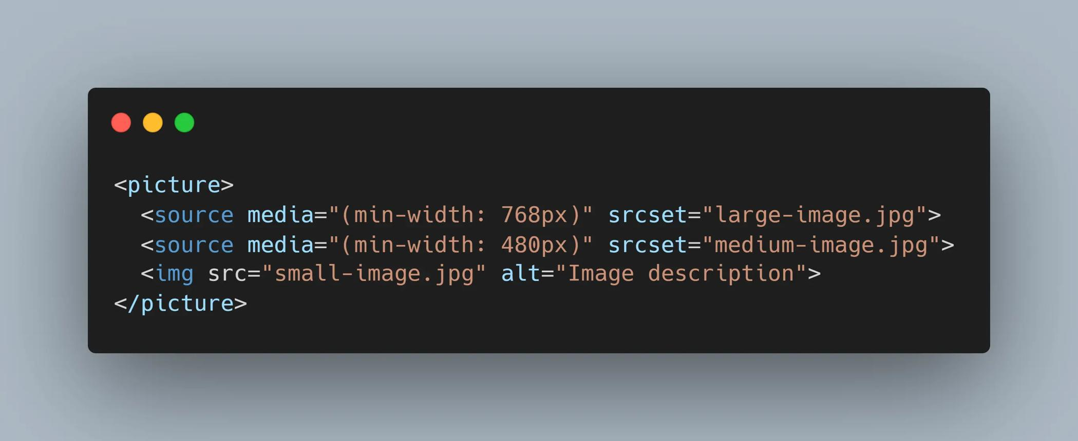
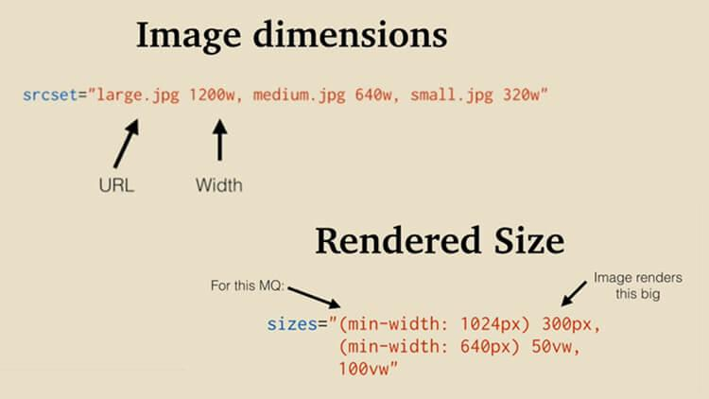
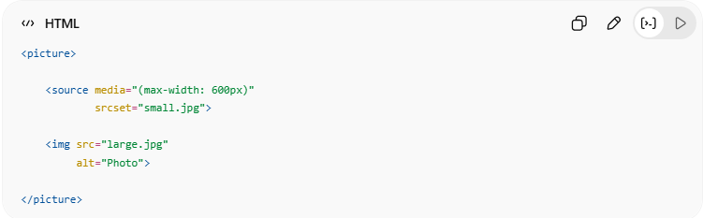
<picture>
<source media="(max-width: 600px)"
srcset="small.jpg">
<img src="large.jpg"
alt="Photo">
</picture>
👉 Different images load for different screen sizes

🔤 Common Uses of <picture>

1. 📱 Responsive Images
# Source: AI Source: Provided by: [Data Path: Persons Table -> ID Column: 1, Name_En Column: Motasem Essam] -> From: [ChatGPT] on [5/6/2026]
📖 Description
Displays different images based on screen width.
💻 Example:
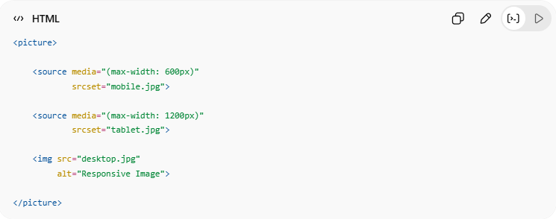
<picture>
<source media="(max-width: 600px)"
srcset="mobile.jpg">
<source media="(max-width: 1200px)"
srcset="tablet.jpg">
<img src="desktop.jpg"
alt="Responsive Image">
</picture>
👉 Mobile, tablet, and desktop can use different images

2. 🖼️ Different Image Formats
# Source: AI Source: Provided by: [Data Path: Persons Table -> ID Column: 1, Name_En Column: Motasem Essam] -> From: [ChatGPT] on [5/6/2026]
📖 Description
Browsers can load the best supported image format.
💻 Example:
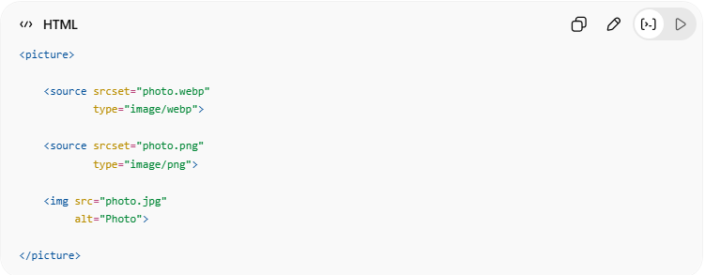
<picture>
<source srcset="photo.webp"
type="image/webp">
<source srcset="photo.png"
type="image/png">
<img src="photo.jpg"
alt="Photo">
</picture>
👉 Browser chooses supported format

3. ⚡ Performance Optimization
# Source: AI Source: Provided by: [Data Path: Persons Table -> ID Column: 1, Name_En Column: Motasem Essam] -> From: [ChatGPT] on [5/6/2026]
📖 Description
Smaller images can load on mobile devices to improve speed.
👉 Faster webpage loading

💻 Example

Full Example
# Source: AI Source: Provided by: [Data Path: Persons Table -> ID Column: 1, Name_En Column: Motasem Essam] -> From: [ChatGPT] on [5/6/2026]
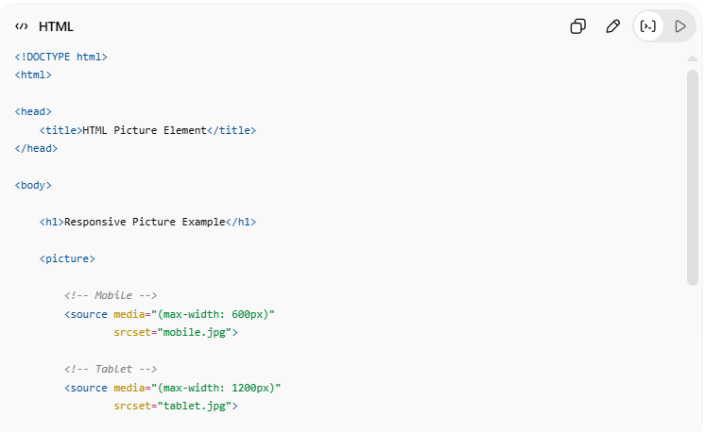
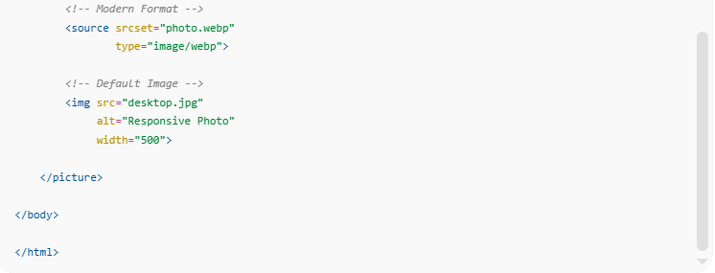
<!DOCTYPE html>
<html>
<head>
<title>HTML Picture Element</title>
</head>
<body>
<h1>Responsive Picture Example</h1>
<picture>
<!-- Mobile -->
<source media="(max-width: 600px)"
srcset="mobile.jpg">
<!-- Tablet -->
<source media="(max-width: 1200px)"
srcset="tablet.jpg">
<!-- Modern Format -->
<source srcset="photo.webp"
type="image/webp">
<!-- Default Image -->
<img src="desktop.jpg"
alt="Responsive Photo"
width="500">
</picture>
</body>
</html>

🧪 What You Can Test
# Source: AI Source: Provided by: [Data Path: Persons Table -> ID Column: 1, Name_En Column: Motasem Essam] -> From: [ChatGPT] on [5/6/2026]

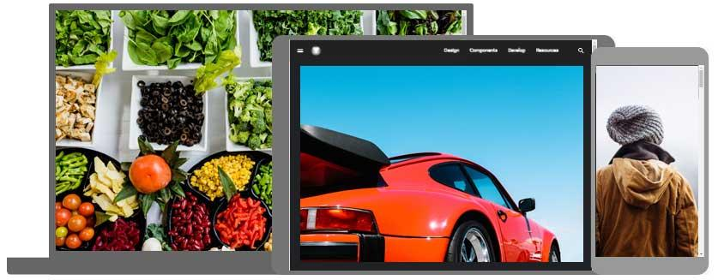

Feature | Result
media | Different image by screen size
type | Different image format
srcset | Alternative image source
<img> | Default fallback image

⚠️ Important Notes

✅ <img> is required inside <picture>
# Source: AI Source: Provided by: [Data Path: Persons Table -> ID Column: 1, Name_En Column: Motasem Essam] -> From: [ChatGPT] on [5/6/2026]
👉 Acts as fallback if no <source> matches

✅ Browser reads <source> from top to bottom
# Source: AI Source: Provided by: [Data Path: Persons Table -> ID Column: 1, Name_En Column: Motasem Essam] -> From: [ChatGPT] on [5/6/2026]
👉 First matching source is used

✅ Useful for responsive web design
# Source: AI Source: Provided by: [Data Path: Persons Table -> ID Column: 1, Name_En Column: Motasem Essam] -> From: [ChatGPT] on [5/6/2026]
👉 Better performance and mobile support

🚀 In short:
# Source: AI Source: Provided by: [Data Path: Persons Table -> ID Column: 1, Name_En Column: Motasem Essam] -> From: [ChatGPT] on [5/6/2026]
The HTML <img> element is used to display images and supports sizing, accessibility, responsiveness, and clickable image links.

